**Updating the Teacher Predictor Model**

Installation

1. Copy TPM_SPM_Analysis.zip into Documents/My Documents folder
2. Right click on TPM_SPM_Analysis.zip and click Extract All
3. Choose a destination folder and note the file path (this will be needed in a later step). Example file path:

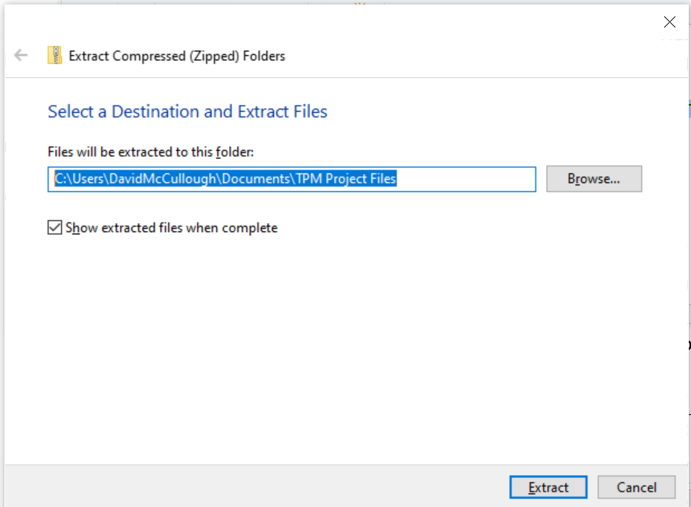

Note: it is highly recommended that you choose a folder on your local hard drive. Storing the TPM on a network drive may result in unstable performance.

1. Click extract
2. Click on the Installation folder
3. Double click on R-3.6.1-win.exe. Follow the prompts, leaving the default installation options
4. Double click on RStudio-1.2.1335.exe. Follow the prompts, leaving the default installation options
5. Double click on Rtools35.exe. Follow the prompts, leaving the default installation options

Updating

1. In TPM_SPM_Analysis is a folder called ‘Data’. This is where raw teacher and student data will need to be placed.
   1. In the data folder is an excel workbook titled “SPM Student Data.xlsx”. This workbook contains student enrollment data, as exported from the SQL server It must include at least the following fields:
      1. YEAR
      2. COUNTY_DISTRICT_CODE
      3. DISTRICT_NAME
      4. SCHOOL_CODE
      5. SCHOOL_NAME
      6. ENROLLMENT_GRADES_PK
      7. ENROLLMENT_GRADES_K
      8. ENROLLMENT_GRADES_01
      9. ENROLLMENT_GRADES_02
      10. ENROLLMENT_GRADES_03
      11. ENROLLMENT_GRADES_04
      12. ENROLLMENT_GRADES_05
      13. ENROLLMENT_GRADES_06
      14. ENROLLMENT_GRADES_07
      15. ENROLLMENT_GRADES_08
      16. ENROLLMENT_GRADES_09
      17. ENROLLMENT_GRADES_10
      18. ENROLLMENT_GRADES_11
      19. ENROLLMENT_GRADES_12

To update the Student Predictor Model, replace SPM Student Data.xlsx with a workbook that includes the most recent year of data. The updated file must contain a single sheet, the columns as titled above, and be titled SPM Student Data.xlsx.

* 1. In the data folder is an excel workbook titled “TPM Teacher Data.xlsx”. This workbook contains teacher data, as exported from the SQL server. It must include at least the following fields:
     1. YEAR
     2. COUNTY_DISTRICT_CODE
     3. COUNTY_DISTRICT_NAME
     4. SCHOOL_CODE
     5. SCHOOL_NAME
     6. EDUCATOR_ID
     7. CATEGORY
     8. SUBJECT_AREA
     9. APPROPRIATELY_CERTIFIED_YES_OR_NO
     10. SUPERVISOR_REGION
     11. SUPERVISOR_REGION_NAME

To update the Teacher Predictor Model, replace TPM Teacher Data.xlsx with a workbook that includes the most recent year of data. The updated file must contain a single sheet, the columns as titled above, and be titled TPM Teacher Data.xlsx.

1. Once the updated SPM and TPM spreadsheets are copied to the Data folder, go to the Start menu and open RStudio.
2. One open, click file, then Open Project. Navigate back to the TPM_SPM_Analysis folder and double click on TPM_SPM_Analysis.rproj
3. In the TPM_SPM_Analysis folder, double click on the “Scripts” folder, and then double click on ‘Update Overview.R’
4. Change the file path (highlighted below) to reflect the folder the TPM project was extracted to:

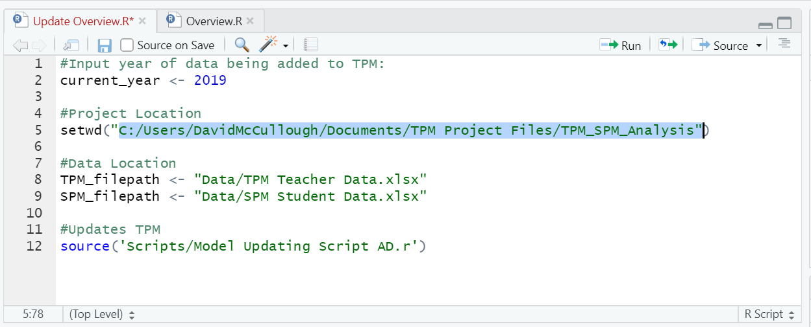

1. Change the value next to current_year to reflect the most recent year represented in the raw data.
2. Click Code > Run Region > Run All.

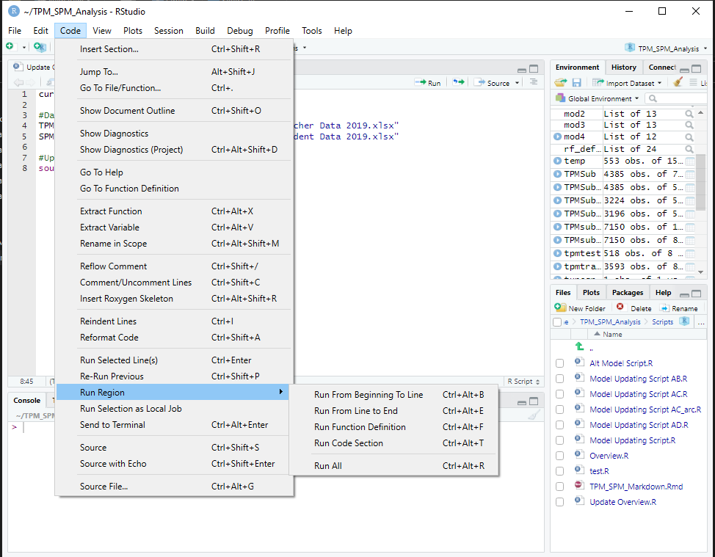

1. The code will take 5-10 minutes to update. Once it’s complete, the TPM dashboard can be use following the instructions below.

**NOTE:** The TPM updating steps only need to be followed whenever new enrollment/teacher data is added. If the TPM has already been updated, skip to the section below to use the TPM dashboard.

**Using the Teacher Predictor Model Dashboard**

1. Open R Studio
2. Click File > Open Project. Navigate to My Documents, TPM_SPM_Analysis, then double click on TPM_SPM_Analysis.rproj
3. In the TPM_SPM_Analysis folder, double click on the “Scripts” folder, and then double click on ‘Overview.R’
4. Click Run App:

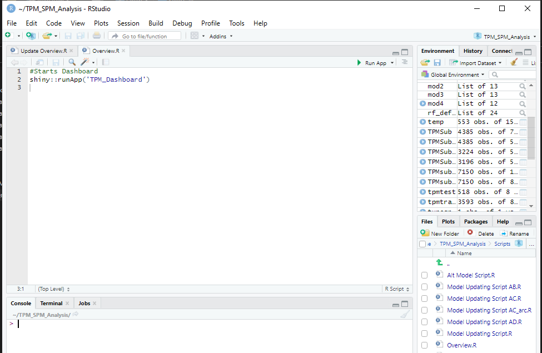

An HTML window will pop up, allowing you to interact with the TPM model output.